W2 Exercise 1.01: Creating a Histogram
Kalpana Renjarla
CT5130 Intro to SQL for Data Analytcs - CRN195
Huseyin Umut Aksu
New England College
07-23-2026

Steps Completed
- Opened the heights.csv dataset in Microsoft Excel.
- Selected the height values in Column A.
- Chose Insert → Insert Statistic Chart → Histogram.
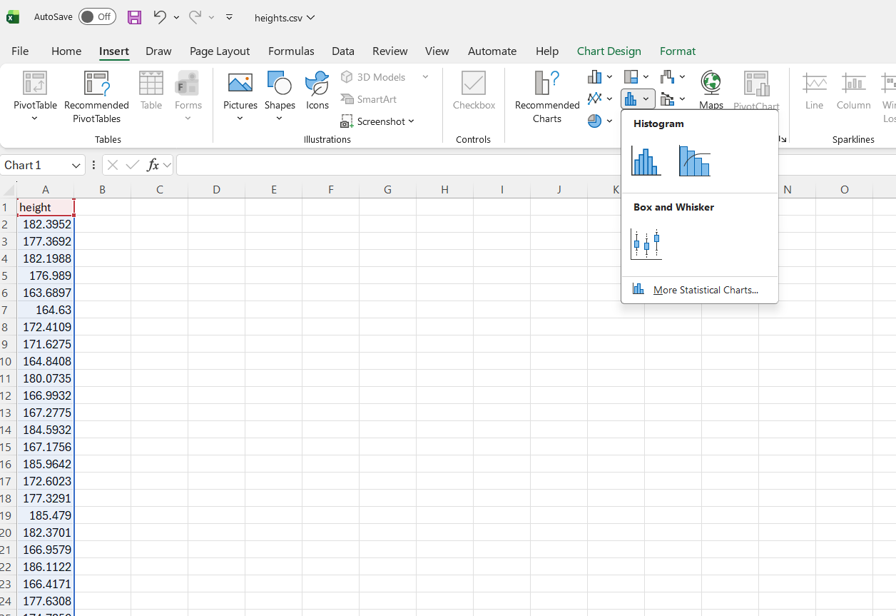
- Renamed the chart Distribution of Heights.
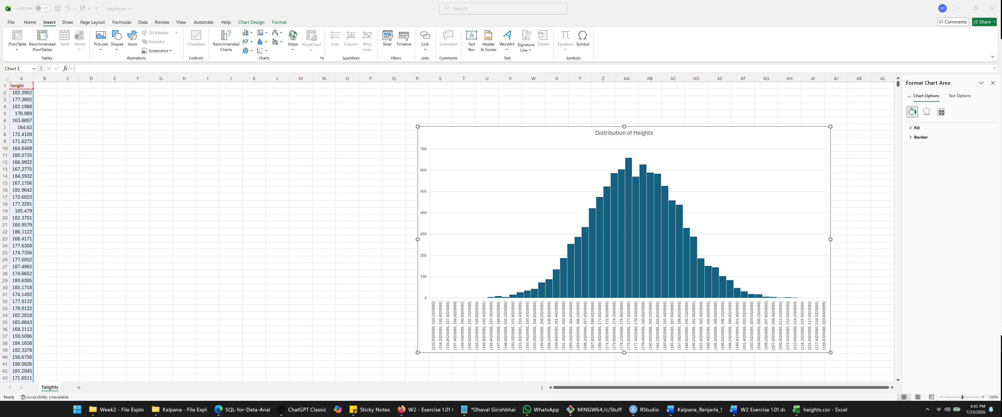
Graph Interpretation
The histogram shows the distribution of the height measurements in the dataset. Most heights are concentrated between approximately 170 and 185 cm. Fewer observations appear at the lower and higher ends of the graph. The distribution is roughly bell-shaped, indicating that most individuals have heights near the average, while only a small number are unusually short or tall.

